
Riverbay Association Newsletter -- June, 2011

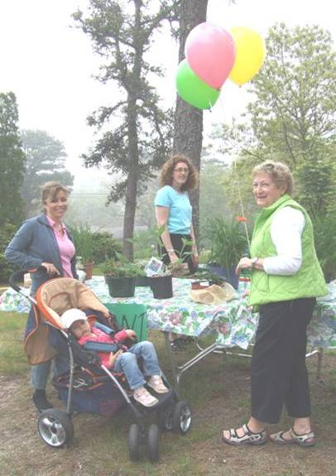
Welcome back to those who traveled to warmer climes but have now returned to lovely Chatham. We hope that you are enjoying spring, such as it is, and are looking forward to the ever too short, but always lively summer season.
One mark of the arrival of spring is the “Riverbay Spring Planting, Clean-up and Plant Swap” event, sponsored each year by the “RBC”—the Riverbay Beautification Committee---chaired by Christie Turner. On May 28th, RBC members and volunteers--ranging in age from 2 to 75 years -- helped to complete planting and clean-up of all 4 signed entrance areas, especially the main entrance at Park Avenue. The 2nd annual Plant Swap event drew a number of residents and about 25 plants changed hands with both plant “givers” and “receivers” seemingly satisfied. This multi-generational group of 20 volunteers demonstrated their hardiness and community spirit by showing up at the Park Avenue main entrance to help with planting, weeding, edging,& clean-up chores. You’ll see several photos of Planting Day here ‘n there in newsletter.
DUES & DO’S
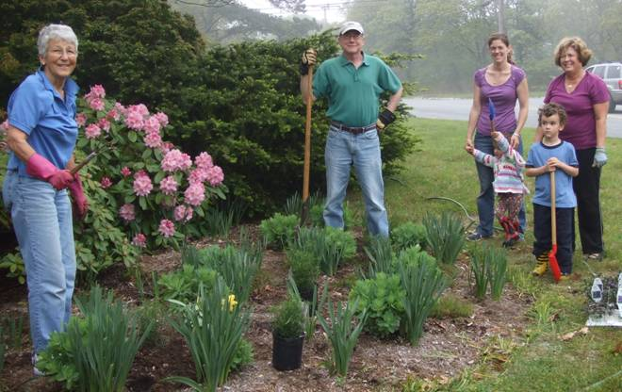
It may seem like only yesterday that you paid your Riverbay Association (RBA) membership dues, but here it is time again. Please consider joining or re-joining the RBA again this year. Enclosed you will find the 2011 Dues Notice and the 2011 Riverbay Volunteer form. Annual Dues remain at $30---less than 9¢ a day---a real bargain! Our fiscal year starts October 1 and ends September 30 but dues are billed in June to catch many of our snow bird residents. Do join us—we love to see new faces in the ‘hood and in the Riverbay Association.

Come 2012, Riverbay will mark its 50th birthday. We have a long way to go to catch up to the Town of Chatham as it celebrates its tercentennial next year, but we never will. What will Riverbay do to celebrate—any ideas?? Your Board of Directors is interested in hearing from you.

WANTED & NEEDED: “Riverbay Garden Buddies”-- spring and summer !
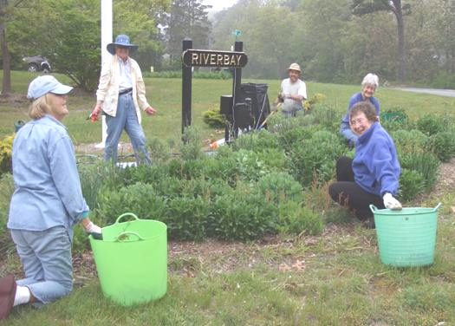
Volunteers are needed throughout the summer to help with weeding and general maintenance of the Park Avenue garden—you pick the week. Just an hour or so of your time is all that we ask---maybe less if we can pair you with a fellow volunteer. “Garden Buddies” make for quick work and you might make a new friend. So why not contact Christie Turner to schedule a time and help out your community—you might even find it fun! Call 508.945.3149 or christie199@comcast.net
Irrigation is available only at the Park Avenue main entrance. Help is needed at Chipping Stone Rd. entrance and the new bed at Riverview and Lakeview Ave. Drought tolerant plants were used in these beds but even those plants need water to get established the first year. If you can help water at the Chipping Stone corner, please contact Ann Reydel at 508.945.1988 or reydel@comcast.net. If you can carry a few pails of water to help at the new garden bed at Riverview & Lakeview corner, please call Bill Cullinane at 508.945.1824 or William.cullinane1@verizon.net
SAVE THE DATE Coming this fall---September 24th
Riverbay Association Picnic—late afternoon
at the Chatham VFW—by the airp0rt
Enjoy the last burger/frank of the season
More details to follow

A note from the prez: “Thank you Riverbay residents who have helped with various projects throughout the year, and especially to those of you serving on the Board of Directors. From time to time some of you may have asked yourself why you said “yes” when Jan came calling, but do know I truly appreciate all of your help & support. Jan Whittaker, President 945 - 0552
Lookin’ good . . . .
One of the main goals of the Association is to help maintain property values in Riverbay Estates. Our homes are often one of our larger investments, so why shouldn’t we take care of our property. All of the Riverbay Beautification Committee members do a great job in keeping our four signed entrance areas lookin’ good year round. A hearty thanks to Jack Zilliox for painting all of the Riverbay quarterboard signposts this year. He was hard pressed for awhile there to find a dry day to do the job. Our gratitude is extended to both Marybeth Richardson and Mike McPherson for all their extra efforts in cleaning-up the Park Ave. islands. A new garden was added at the corner of Riverview Drive and Lakeview Ave. this year. Some drivers--certainly not Riverbay residents--were taking short cuts and driving behind the street sign. They will be in for a surprise now if they try that. Thank yous are extended to Christie Turner for the planting work at that garden, Tom Geagan for providing and delivering the rocks, and to Bill Cullinane who will provide and coordinate the necessary H₂0. Further up Lakeview at the corner of Round Cove, Karen Ginter continues with her gardening handiwork. Looking good, don’t you think…
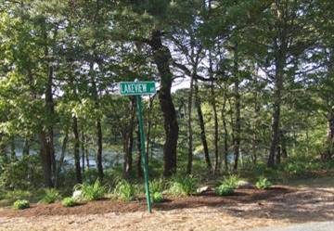
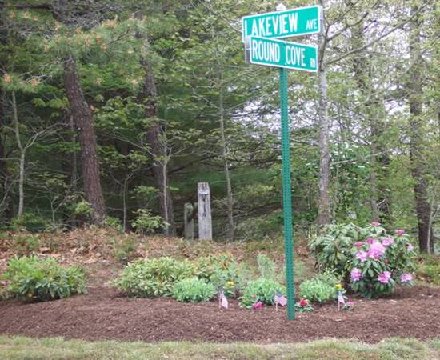
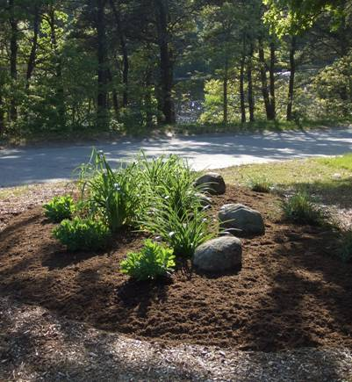
▼ Karen’s Corner

Corner of ▲ and ►
Riverview and Lakeview

Riverbay Association Members -- now don’t forget your “Perks ~~~

♦♦ Riverbay Directory -- just updated last December—listing of all Riverbay residents. To obtain a copy, call Jan Whittaker, Association “prez”, at 508.945.0552 for local pick-up; if off-Cape or out-of-state, contact Jean Carey, Membership chair, at 508.945.0321 or via e-mail at jeancarey192@comcast.net
♦♦ Business listing -- Coming later this year -- a free business listing page on our web site for Association members. If you need a plumber, an attorney, a realtor, etc. wouldn’t it be nice to know if there was one right here in our neighborhood. Keeping your business local is especially GOOD business!

Leavin’ town---how sad . . . .
Now why would you want to do that…but, if you do, free listings on the REAL ESTATE page of www.riverbay.org are available to Association members. Check it out—3 new properties are now listed for sale. Aren’t you a wee bit curious to know what homes in Riverbay have sold for over the past year?

Yoo Hoo—WANTED—Riverbay e-mail addresses
Please help us to ♦♦Save $$$ ♦♦Go green ♦♦Improve communication
So far, over 200 Riverbay households have taken the leap. Your address will NOT be shared with any outside entity. A small number of messages are returned after a message is sent to the Riverbay e-mail group. If you would like to be added to the Riverbay group or if your address has changed, please contact Ann Reydel, our webmaster, at reydel@comcast.net. At some point in the future, we may go electronic with some issues of the Riverbay Newsletter. The cost of a full mailing---375 issues---is significant when you include paper, postage and printing. We think your dues could be used in better ways.

RIVERBAY ASSOCIATION
P.O. BOX 623
No. Chatham, MA 02650

Riverbay.org

